Home SIEM Lab

In this lab I will configure a web Server application using XAMPP hosted on my local machine, Splunk will be configured to collect data from log files and trigger alerts if SQL injection(SQLI) or cross site scripting(XSS) are performed.

Apache will be used to host the Server and create an interface for the frontend, I will create a data base on the backend using MySQL that will hold information that is input onto the website. PHP will be the middle man interacting with both the backend and frontend taking input from the HTML pages and storing them in the SQL database. Splunk will be configured watch and collect data from the PHP log files and trigger an alert if it detects SQLI or XSS attempts.

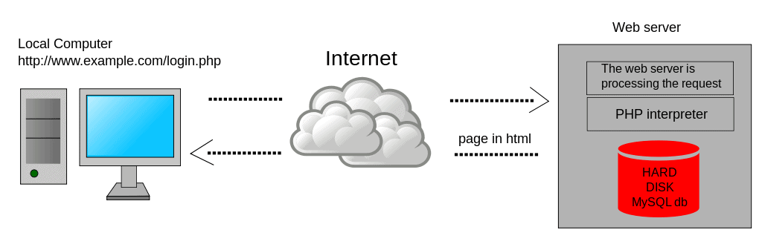

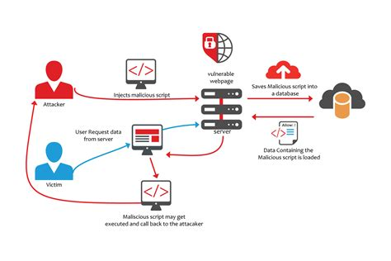

XAMPP Services and Ports

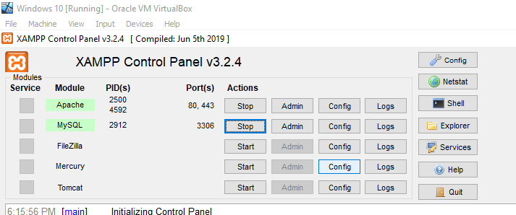

MySQL server running on Apache local host(127.0.0.1) with php configurations

php config files

php config to create input for database variables

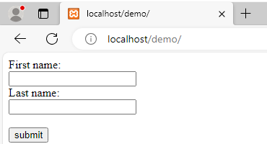

php config to push variables to MySql and display variables on web browser

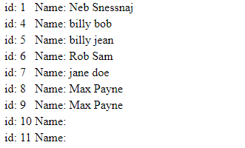

Selecting host view a data summary from splunk

Splunk detecting input from Web Application

Performing SQLI and XSS on the web application to modify the backend



Creating Alerts for Splunk to detect SQLI and XSS

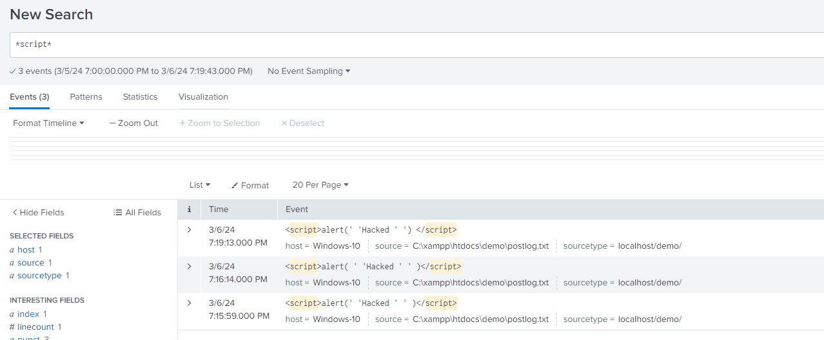

Realtime detection of triggered events

